OSSP_Practical
Practical-4:

Write a C program where a parent process creates multiple child processes and synchronizes their completion using wait() and waitpid(). Compare the behavior of both functions.
Extend the program to demonstrate how improper synchronization can lead to zombie processes. Use appropriate system calls to prevent zombie processes.

Code:
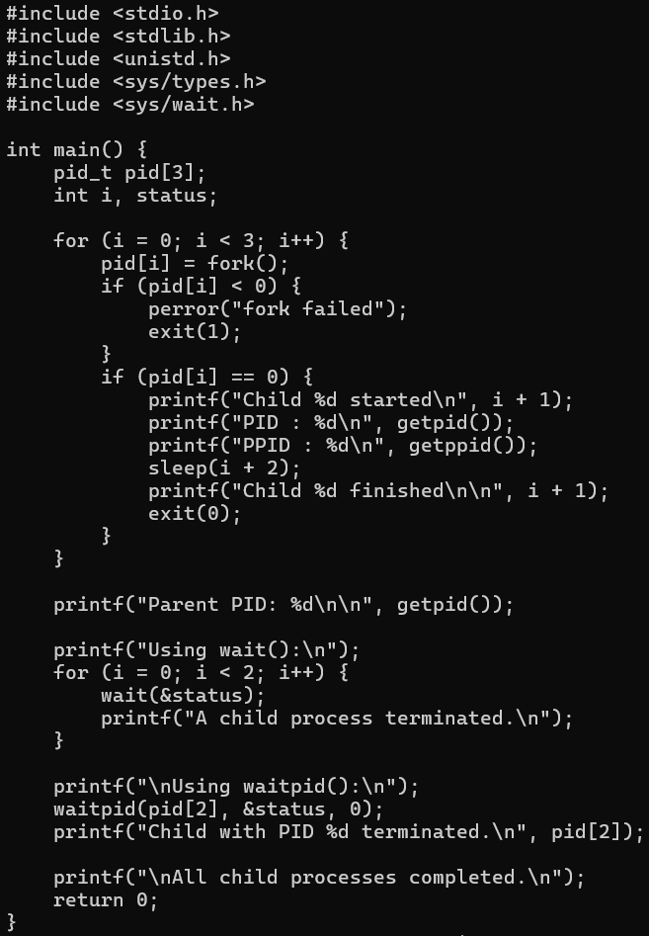
OUTPUT:

